OPINION

The problem is white supremacy

‘Systemic racism’ conveys the pervasiveness of racial oppression, but white supremacy goes further by indicating that there is a rigid nexus of power that protects and enforces it.
By Barbara Smith Updated June 30, 2020, 12:01 p.m.

https://www.bostonglobe.com/2020/06/29/opinion/problem-is-white-supremacy/

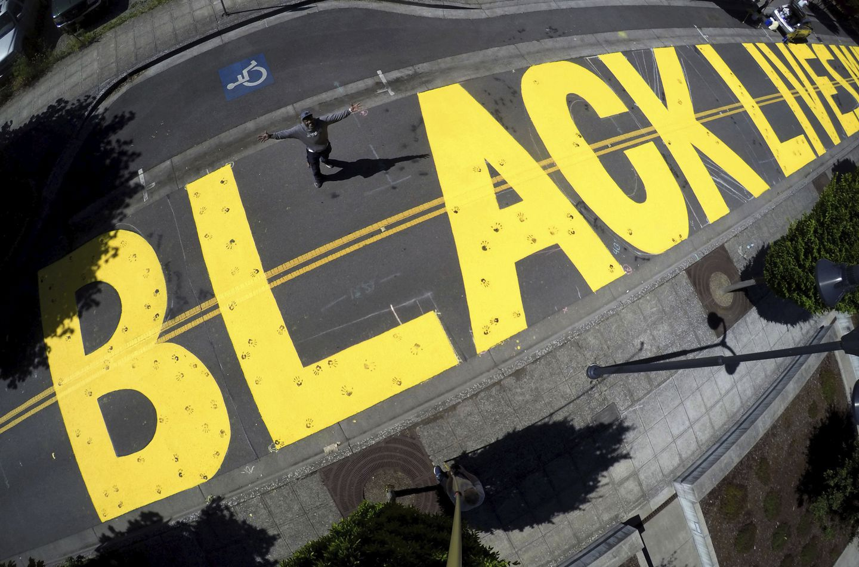Shawn Goddard, with Eugene BIPOC Art Collective, stands in the middle of a Black Lives Matter mural he and 20 other artists created on East 8th Avenue in front of the Federal Courthouse in Eugene, Ore., for Juneteenth, Friday June 19, 2020. The BIPOC Project aims to build solidarity among people of color in order to dismantle white supremacy and advance racial justice.CHRIS PIETSCH/ASSOCIATED PRESS
In her novella “In Darkness and Confusion,” Ann Petry provides a wrenching fictional account of the 1943 Harlem race riot. The story is told from the perspective of William, a working-class husband and father whose son has been drafted into the Army and sent for training to the no man’s land of rural Georgia. William and his wife, Pink, are worried because they have not heard from Sam for a long time. Through a chance encounter with one of Sam’s friends, who had been stationed at the same camp, William discovers the reason Sam’s letters stopped. He is in prison, sentenced to 20 years of hard labor for shooting the military police who shot him for refusing to move to the back of a segregated bus.
The day after William finds out about his son’s fate, Harlem explodes when a white police officer shoots a Black soldier. William and Pink’s grief about Sam and their pent-up fury from a lifetime of racial assaults propel them to join the rioters. Petry brilliantly illuminates the logic of rioting by revealing her well-drawn characters’ inner lives.
Why is this story, written almost 80 years ago, so relevant to what we face today? In 1943, the armed services had not been desegregated, Brown v. Board of Education had not been decided, the Civil Rights Act and the Voting Rights Act had not been passed, affirmative action did not exist, and no Black person had ever been elected president. In 2020, all of these markers of racial progress and many more are part of the historical record, yet Minneapolis and the entire country have erupted for the very same reason that Harlem did in 1943: A white police officer cavalierly executed a Black man. The reason America’s pattern of racial terrorism keeps repeating is because the system of white supremacy that spawns the terrorism remains intact.
Despite the hand-wringing that occurs when the nation’s racial value system gets exposed, usually by unspeakable acts of violence, the reality is that this country has never done anything to eradicate the root cause of these atrocities. America abolished chattel slavery, but quickly instituted peonage, Jim Crow, and mass incarceration; it extended civil rights then proceeded to erode them, especially voting rights; it ended legal segregation but preserved widespread de facto segregation in schools, housing, and jobs; and despite initiating affirmative action, allowed employment discrimination and vast economic inequality to persist.
Because the power structure has always refused to acknowledge the institution of white supremacy, many people do not believe it exists, and most people are confused about what the term even means. Toxic as such beliefs are, white supremacy is not merely the individual delusion of being superior to Black people. Institutionalized white supremacy does not need individual bigotry in order to function, because it is a universal operating system that relies on entrenched patterns and practices to consistently disadvantage people of color and privilege whites.
Efforts to diminish racial discrimination in specific socioeconomic sectors, programs to improve race relations, or attempts to get rid of individual prejudice, which are typical focuses of racial reform, leave the overarching system of white supremacy intact. Multiple lynchings during the coronavirus pandemic — which has disproportionately killed Black, brown, and Indigenous people, while expecting them to risk their lives at low wage jobs to make life comfortable for everyone else, at the same time that people of color are experiencing much higher rates of joblessness and poverty — perfectly illustrate how relentlessly the engine of institutional white supremacy operates, privileging some and grievously destroying the lives of others.
In the aftermath of George Floyd’s execution, there is much discussion about the urgent need to change the culture of policing. Certainly this must occur, but it is naive to think that the culture of policing can be changed without addressing what created that culture to begin with. Our current version of policing is rooted in the slave patrols whose job was to capture people who had escaped, to criminalize Black bodies, and to curtail Black freedom. Using extreme violence to hold onto property — that is, other human beings — was universally accepted and legal.
Police who act as an army of occupation in poor communities of color and as the front-line of mass incarceration have direct links to the tradition of the paddy rollers of the antebellum era. To change the culture of policing, we need to look at where that culture originated. We will also need to recognize that contemporary policing and the entire criminal injustice system are themselves essential to maintaining white power and control. Changing the culture of policing would require getting rid of the soil in which it grows. Changing the culture of policing necessitates eradicating white supremacy.
There is little reason to believe, even in the midst of a conflagration, that the United States will change course and begin the Herculean task of dismantling this fundamentally undemocratic system. But what if it did?
What would happen if we began an honest national dialogue about the disaster of white supremacy? What if we consistently used the words “white supremacy” so that everyone would have accurate language for conceptualizing what is actually going on? The way we describe this problem matters. For example, “systemic racism” clearly conveys the pervasiveness of racial oppression, but white supremacy goes further, by indicating that there is a rigid nexus of power that protects and enforces it.
What if there were informational campaigns to develop shared understandings about the ways white supremacy infiltrates every facet of life in the United States: policing, courts, prisons, health care, education, housing, the economy, the environment, religion, science, technology, the arts, sports, and more. Minneapolis City Councilor Andrea Jenkins has called for racism to be declared a public health emergency. What if there were public service announcements, like those we have seen during the pandemic, that provided data, cultural resources, and historical context about the many dimensions of systemic white supremacy as well as steps for challenging it?
What if we launched an initiative on the scale of the Marshall Plan or the space race to eradicate white supremacy? What if it were led by experts with the most detailed knowledge of how white supremacy, in tandem with racial capitalism, operates — that is, poor and working-class people of color? What if these experts partnered with researchers, advocates, and practitioners to provide exhaustive documentation, analysis, and comprehensive recommendations for ending the scourge of white supremacy once and for all? What if . . . ?
After more than five centuries, there is much work to be done. Until this moment, I have had little reason to believe that it ever would be. But millions of people of all races and backgrounds in the streets day after day shouting that they are fed up with America’s racial status quo and demanding change give me cause for hope.
It is much more likely, however, that the powers that be will offer band-aids and half measures, thus ensuring that white supremacy remains intact. Until this nation confronts white supremacy and commits to demolishing it brick by brick, police brutality, vigilante violence, and rampant inequality will continue, and America will move closer to becoming a failed state.
Barbara Smith is an author and independent scholar who has been active in movements for social, racial, and economic justice since the 1960s. She is the coauthor of the Black feminist “Combahee River Collective Statement.” In 2005, she was nominated for the Nobel Peace Prize. Follow her on Twitter @thebarbarasmith.

- Trump’s ‘Roger Mudd’ moment augurs ill for his reelection
- Downward, Christian soldier
- The Great Trumpkin battles the reverse curse
- The problem is white supremacy
- Don’t be a Karen. Be a Joan.
- The statistical paradox of police killings
- Advice for Biden: Let Trump implode
- Systemic racism has dug its way into the housing landscape
- Filipino journalist tops ‘10 Most Urgent’ list of press freedom cases
- America has a policing problem. It’s bigger than you think

