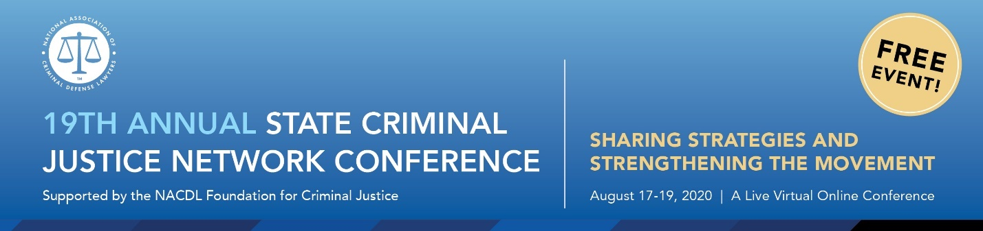

August 2020
Dear Friends,

Welcome to NACDL’s 19th Annual State Criminal Justice Network Conference: Sharing Strategies and Strengthening the Movement. I would like to take this opportunity to welcome you on behalf of Chris Adams, NACDL President; the NACDL Foundation for Criminal Justice; and the State Legislative Affairs Committee.

To say that this has been a challenging year would be an understatement. The events unfolding across the country today renew a long-standing call for fundamental changes to our nation’s institutions, particularly our criminal justice system. The onslaught of the COVID-19 pandemic has greatly impacted the work that we all do. Many of the most serious challenges posed by the COVID-19 pandemic relate to our criminal justice system and particularly our nation’s prisons and jails. It has been widely reported that the nation’s top infection hot spots are correctional facilities, yet not enough is being done to help curb infection rates in these facilities. And despite the tireless efforts of advocates to get people released during the pandemic, decisionmakers have been reluctant to do so. We also once again find ourselves grappling with the continued killings of more and more Black people by law enforcement. The cries for justice have largely gone unrecognized and unfulfilled.

Yet in spite of all that has transpired, this past year has proven that not only are politics local, but state legislative advocacy has the potential for driving reform, as you will hear from many at this conference. While many of our efforts at reform seem insurmountable, we are encouraged by all of you who, in various ways, support reform and equity in the criminal justice system. Special sessions at the state level could provide opportunities for long-awaited reforms.

This year's free virtual conference offers participants an opportunity to hear from experts on state criminal justice reform. Since the inception of the SCJN Conference, the expanded participation of both practitioners and the advocacy community has enabled NACDL to bring together individuals directly affected by the criminal justice system and stakeholders who seek reforms that will have a lasting impact on our communities. We are excited to be able to provide these valuable resources to an expanded audience this year!

In addition, NACDL continues to provide advocates and its state affiliate organizations with resources aimed at assisting them with their legislative efforts. Below please find some of NACDL’s state advocacy resources:

- NACDL’s State Criminal Justice Network Listserv provides a medium to exchange information, share resources, and develop strategies for promoting rational and humane criminal justice policies. The SCJN listserv does not require membership in NACDL to access. To join, please send a message with your full contact information to advocacynetwork@nacdl.org.

- Legislative Action Alerts: As an affiliate or partner organization, you have the opportunity to utilize NACDL’s advocacy platform to disseminate legislative action alerts to prompt our network of members advocates to contact their elected officials. If interested, please see ‘NACDL’s Legislative Action Alert Collaboration Form’ in your SCJN conference materials for more information.

- NACDL Expert Witness Fund is available to affiliate and partner organizations who seek to bring in a witness to testify at a legislative hearing or commission meeting. Funds are limited and require an application.

- State Legislative Tracking: NACDL tracks over 30 state criminal justice issues congruent with NACDL’s strategic goals. These reports are shared monthly through our SCJN newsletter and are available on our website.

- SCJN Electronic Newsletter: This monthly newsletter features a snapshot of NACDL's state criminal justice priorities, as well as, recent internal and external criminal justice reports, information on upcoming events, webinars, current state legislative reform efforts, legislative tracking, action alerts and more.

- SCJN National Advocacy Calls on Developing Legislation: These teleconferences feature an expert on an issue area and are designed to educate criminal defense lawyers and advocates across the country on a variety of criminal justice issues.

For information on any of these resources, please contact mreid@nacdl.org. To learn more about NACDL’s State Criminal Justice Network, resources and upcoming programs visit: https://www.nacdl.org/Landing/StateCriminalJusticeNetwork

Again, welcome to the 19th Annual State Criminal Justice Network Conference: Sharing Strategies and Strengthening the Movement. We look forward to your participation.

Sincerely,

Monica L. Reid, Director of Advocacy
National Association of Criminal Defense Lawyers

